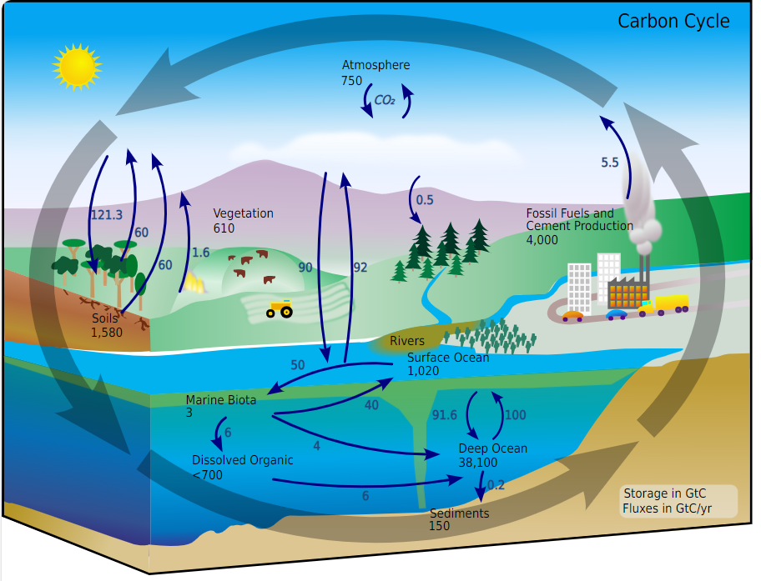

***Note –*** *Storage of CO2 is in gigatons of carbon (GtC); flux or exchange of carbon is in gigatonnes of Carbon per year (GtC/yr). one gigatonne is 1,000,000,000,000 tonnes of CO2. Each tonne of CO2 takes up 556 m3 of space*

**Carbon Cycle Worksheet**

1. Name all the places where carbon exists (nine):
2. List three roles that plants and trees perform in the carbon cycle on land:

a. Absorb…

b. Release…

c. Store …

1. How does carbon get from the atmosphere into fish and then into the ocean sediment? The chain is started for you.

***dissolve***

atmosphere ocean

1. Can carbon get from the deep ocean back into the atmosphere? If yes, explain how.

1. What are two major ways that humans affect the carbon cycle?

a.

b.

1. (a) How many gigatonnes of carbon are exchanged from terrestrial vegetation to the atmosphere each year and what is this process called?

(b) How long does it take for carbon to be deposited into deep stores within marine sediments and sedimentary rocks? (estimate)

(c) How long does it take for carbon to be removed from deep stores (usually by mining or drilling of oil and coal deposits)? Why is the time taken for this such an important factor in global warming?

(d) How much carbon is emitted into the atmosphere through fossil fuel combustion each year?

(e) How much carbon is exchanged between the oceans and the atmosphere each year?

**\*\***(f) Complete the following table listing: the ten sites where carbon is stored, the amount of carbon in each, and the percentage of carbon stored in each.

|  |  |  |
| --- | --- | --- |
|  |  |  |
|  |  |  |
|  |  |  |
|  |  |  |
|  |  |  |
|  |  |  |
|  |  |  |
|  |  |  |
|  |  |  |
|  |  |  |